Name: Rasha Mansour

ID:1210773

**1.5 Post Lab**

• Draw the logic diagram showing the implementation of the following Boolean equation using “NAND” gates

1. F = AB (CA).

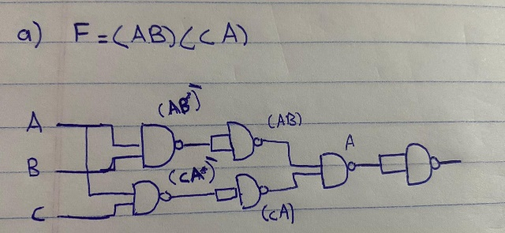

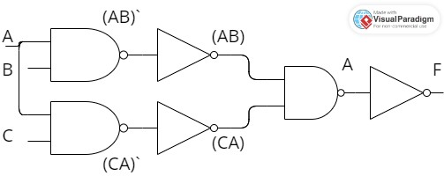

1. F= (D.A) + (C.B)

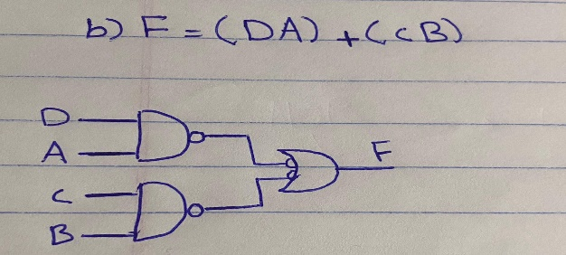

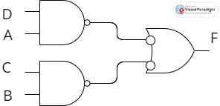

1. F = XZ + Y’Z + X’YZ

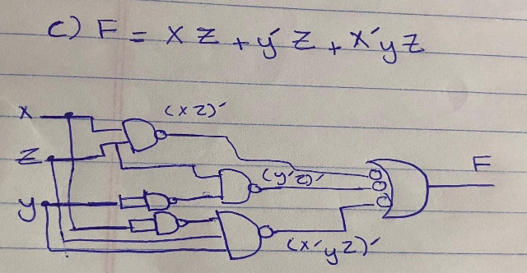

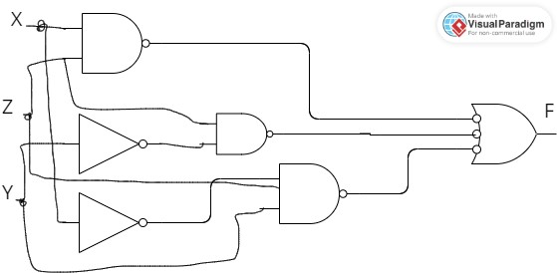

• Draw the logic diagram of the following Boolean equations using NOR gates.

1. F=(A+B) (CD+A)

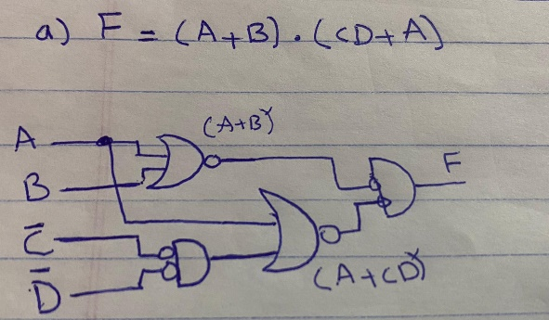

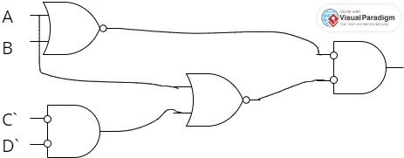

1. F= (ABC+D) C

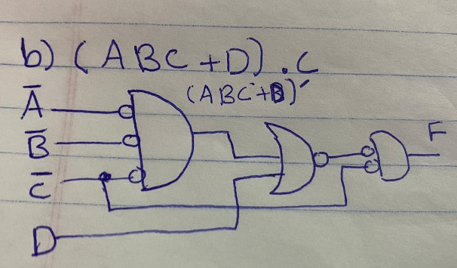

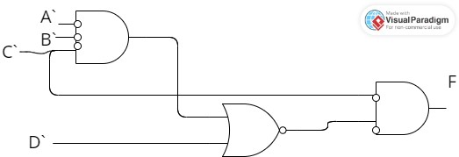

1. F = (X+Z) (Y’+Z) (X’+Y+Z)

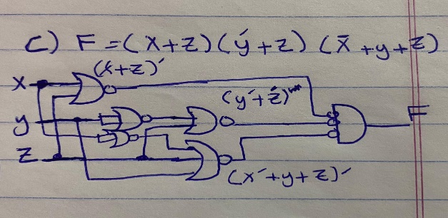

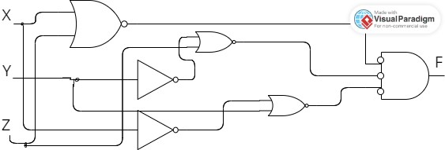

• Implement the OR operation using AND, NOT gate. Draw the logic diagram and write the Boolean equation.

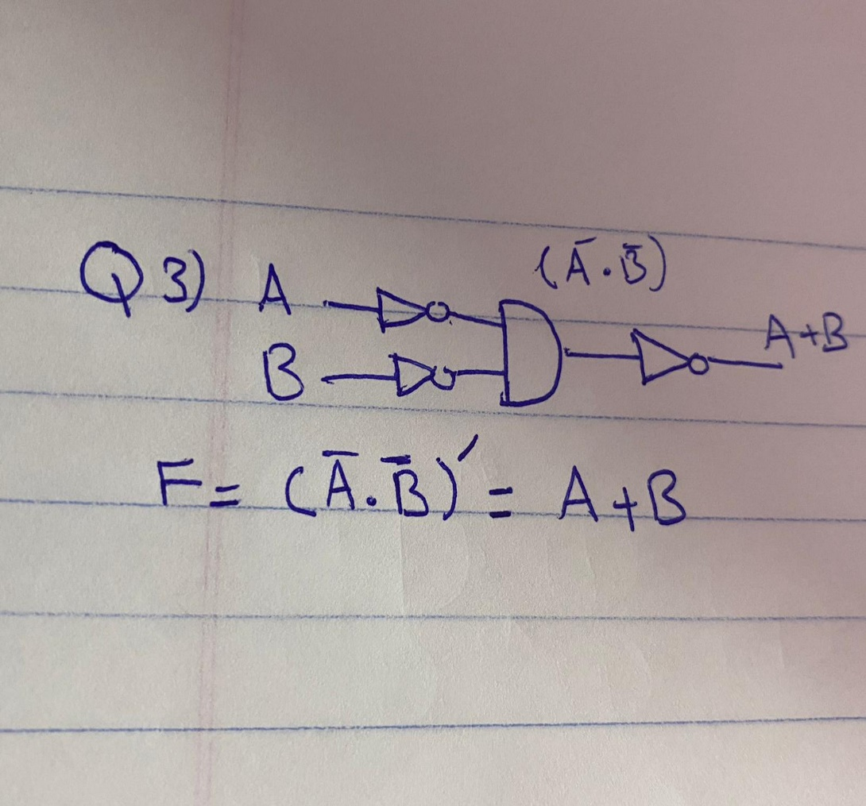

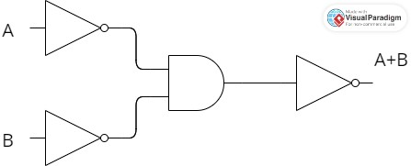

• Implement the AND gate using OR, NOT gate. Draw the logic diagram and write the Boolean equation.

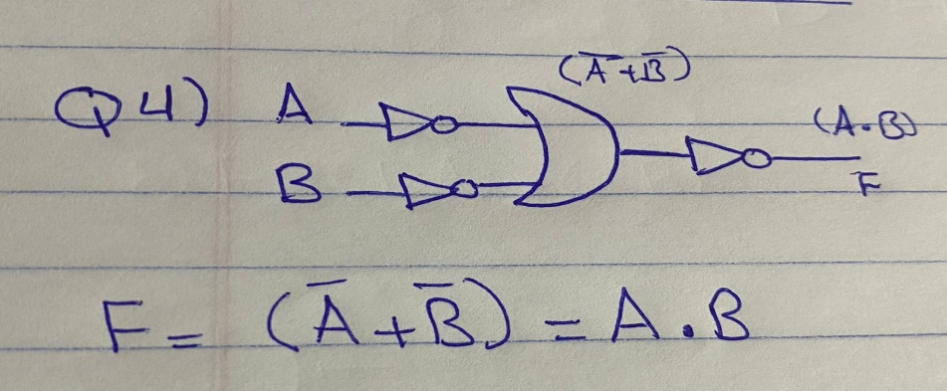

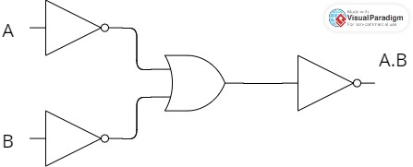

• Prove that the equality operation Fl =AB+A’B’ is the inverse of exclusive OR operation F2=AB’+A’B (use Demerger’s theorem).

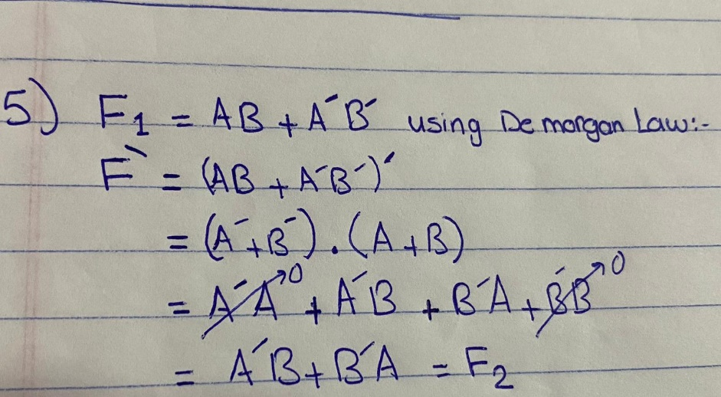

• Show how is it possible to reduce Boolean expressions using the Karnaugh map:

1. F1 = A’B’C + ABC’ + A’BC’ + AB’C

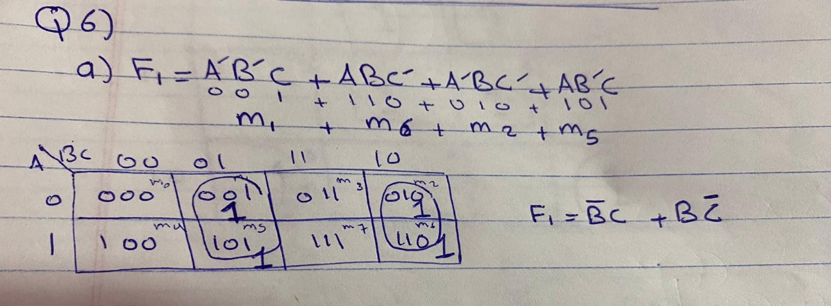

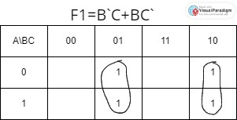

1. F2=A’D+A’C+BD+AB’D’

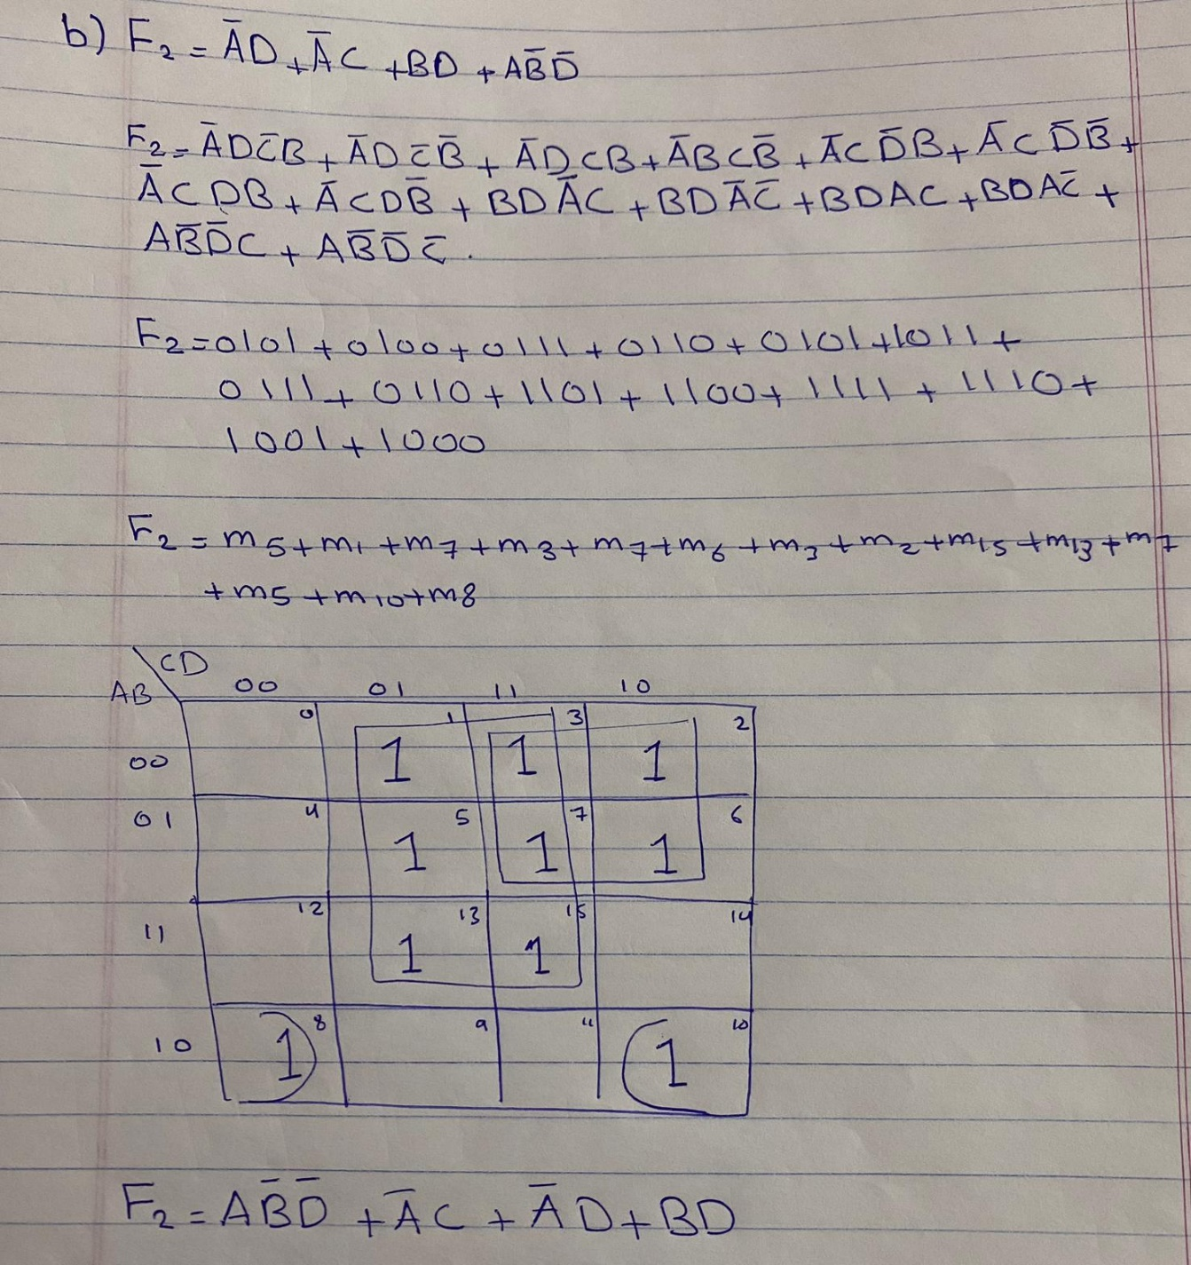

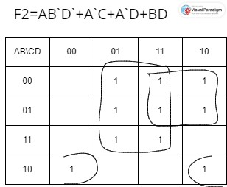

1. F3= A'BCD + ABCD' + A'BCD' + ABCD'

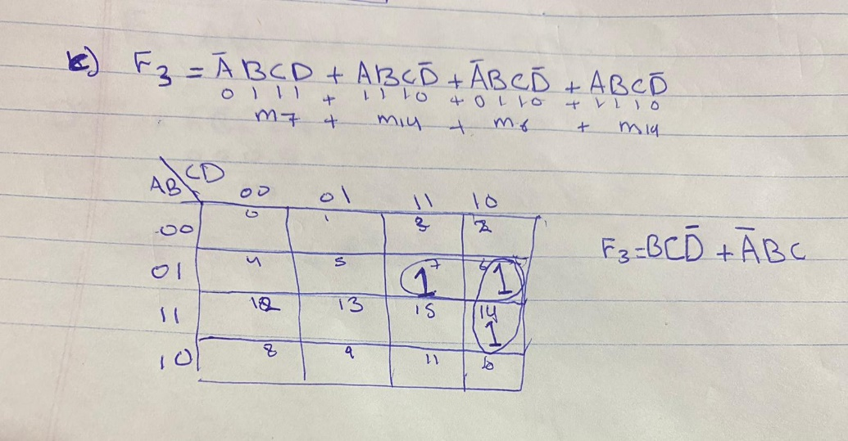

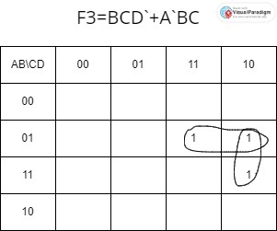

1. F4= A'B'C'D' + AB'CD' + A'B'CD' + A'BC'D'

